Transcontinental
- AutoGO.ca
- ELLE CANADA

Schools Plus program expanding in Aylesford: Glavine
Published on May 23, 2014
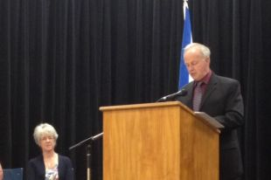
© Nancy Kelly
Students and families in communities throughout Nova Scotia will have greater access to services and after-school programs with a multi-year expansion of SchoolsPlus and more mental health clinicians in schools, Health Minister Leo Glavine announced May 23 in Aylesford.
Students and families in communities throughout Nova Scotia will have greater access to services and after-school programs with a multi-year expansion of SchoolsPlus and more mental health clinicians in schools.
Students and staff gathered at schools in Aylesford, Glace Bay, Inverness and New Glasgow May 23, for the announcement of four new hub sites.
"More students, families and communities are now accessing a full range of support services that address their unique needs through SchoolsPlus," said Karen Casey, education minister.
"Important services like homework support, health-related information, guidance and mental health counselling are delivered in a safe, comfortable and familiar location for families."
The Department of Health and Wellness is providing funding to add 10-and-a-half mental health clinician positions to support SchoolsPlus sites across the province.
"Mental health clinicians are an important part of the collaborative SchoolsPlus program," said Health Minister Leo Glavine, during the opening at St. Mary's Elementary in Aylesford, which will serve nine more schools.
"Now more students across the province who are experiencing a mental health issue or a mental illness will have access to the support and care they need."
SchoolsPlus brings a range of mental health services and other health programs together with mentoring, social work, homework support and justice services into schools where children, youth and families can easily access them.
"Having a mental health clinician in schools reduces barriers that rural families face, like transportation and the stigma of accessing mental health services," said Megan Saunders, SchoolsPlus mental health clinician for the Annapolis-Bridgetown family of schools.

